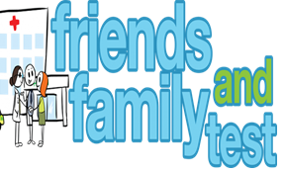
HAVE YOUR SAY TO IMPROVE YOUR CARE!
COMPLETE OUR SHORT QUESTIONNAIRE ON HOW LIKELY YOU ARE TO RECOMMEND OUR SURGERY TO FAMILY AND FRIENDS.
We have been collecting your replies and below are our results for
January 24
Very Good | Good | Neither Good/nor poor | Poor | Very Poor | Don’t Know
30 | 5 | 1 | 0 | 0 | 2

Recent comments:
- Prompt and caring service.

- You are an amazing practice.
- Always very accommodating and have appointments.
- My experience since joining the surgery has been excellent.
- Doctors and nurses are lovely.

